Lab_Day-2 ANP-C9180 (Operators)

1. **Calculate the multiplication and sum of two numbers .**

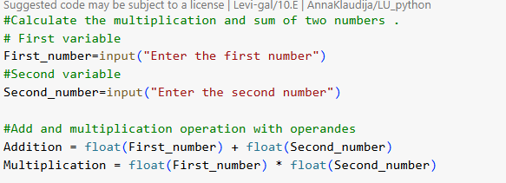

**Output:**

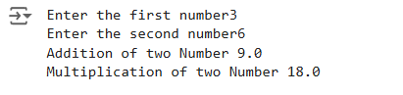

1. **Declare two variables and print that which variable is largest using ternary operators .**

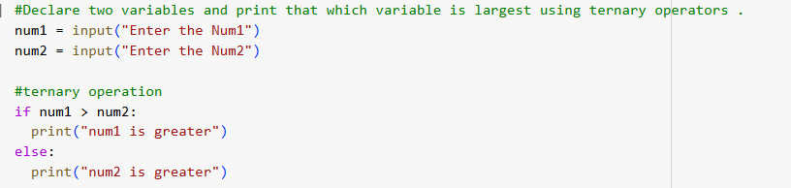

**Output:**



1. **Python program to convert the temperature in degree centigrade to Fahrenheit.**

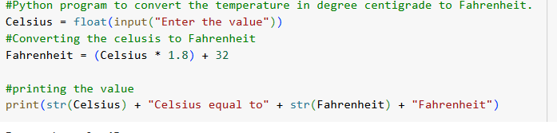

**Output:**



1. **Python program to find the area of a triangle whose sides are given.**

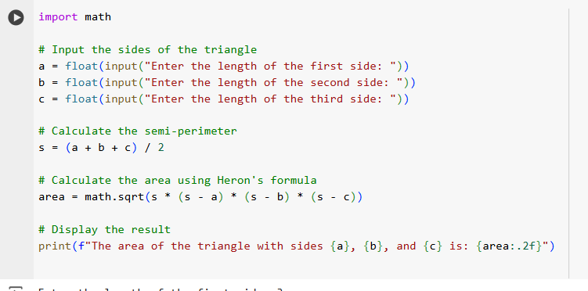

**Output:**

